Model description
The peripheral auditory model is slowly evolving and improving. This account represents the model as it is currently used in our laboratory. The current implementation in MATLAB is called MAP1_14. The most recent published detailed account is Meddis (2006). When the current model deviates from the published account, some indication is usually given below. The most authoritative source for parameters is the current ‘Normal’ MAPparameters file. This document is not automatically updated when the parameters are changed for some reason.

The model is for guinea pig and consists of a cascade of stages:
Outer middle ear
Basilar membrane
Inner hair cell
Stereocilia
Receptor potential
Calcium influx
Auditory nerve/IHC synapse
Refractory Effect
Cochlear nucleus sustained chopper (CS) unit
Brainstem level 2 neurons

All units are international units.
The model is evaluated at a sample rate ≥ 44100 Hz.

Stimulus
The input to the model is the acoustic pressure waveform expressed in Pascals.

Middle-ear filtering
External resonance is modeled as a bandpass filter with sound pressure as the input and output. The filter used is a 1st -order Butterworth filter with a lower cut-off of 1 kHz and an upper cut-off of 4 kHz.

The waveform is converted from pressure (Pa) to tympanic membrane (TM) displacement (m) by applying a low-pass filter (cut-off 50 Hz) and a scalar (e.g. 45e-9 m/Pa.).

Stapes displacement is modelled by applying a high-pass filter to the TM displacement. This is a 1st- order Butterworth filter with cut-off frequency of 1000 Hz. These parameters were chosen to model the intra-operative, human stapes velocity data of Huber et al. (2001).

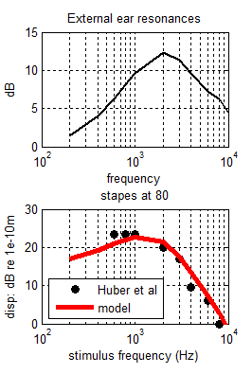
Figure 1. Top: Model external resonance. Bottom: stapes displacement comparison of model output with data from Huber et al. 2001
The stapes displacement is then subject to a variable attenuation (acoustic reflex) derived below on the basis of the brainstem response modeled as a negative feedback loop.

Mechanical filtering: DRNL filter
The filtering of the BM is modelled with a ‘Dual-Resonance-Non-Linear’ (DRNL) filter architecture that has been described and evaluated more fully elsewhere (Meddis et. al., 2001; Lopez-Poveda and Meddis, 2001; Sumner et al., 2003b). The input is stapes displacement, x(t).

The BM is divided into a number of discrete locations identified by its best frequency (BF). The BFs of these locations are normally equally spaced on a log scale between two values (e.g. 250 Hz and 8 kHz)

The DRNL filter consists of two parallel pathways, one linear and the other non-linear, whose outputs are summed to produce an output, v(t) representing the displacement of the cochlear partition (s).

The nonlinear pathway consists of the following cascaded sequence;
1) 3 identical first-order gammatone filters,
2) a compression function,
3) 3 identical gammatone filters.

All gammatone filters in the nonlinear pathway at a specific location on the BM have the same bandwidths (nlBW).

The bandwidth of these filters (nlBW) varies between along the BM and are computed using a linear function

p=0.2895, q=250
nlBW(BF)= p * BF+ q

The CF of the nonlinear path gammatone filters (CF_{Nl}) is set to BF.

The compression function is linear up to a displacement known as the compression threshold (c_th).

v_{t}= SIGN(x_{t}) x a|x_{t|} , |x_{t}| <= c_th

When the displacement will be greater than c_th, the portion greater than the displacement threshold is compressed.

v_{t} = SIGN(x_{t}) × c_th + SIGN(x_{t}) × b|x_{t}|^{ν},
|xt|>c_th

where a, b and ν are parameters that have the same value along the cochlear partition (see Table 2). This function is slightly different from that previously published.

The linear pathway consists of the following cascaded sequence;
1) a scalar, g, representing gain or attenuation,
2) a cascade of three identical gammatone filters.

The CF (linCF) and bandwidth (linBW)of the gammatone filter are specific to the location along the cochlear partition . The CF of the linear pathway (linCF) is not the same as the CF of the linear pathway which is always the same as BF.

p=153.13, q=0.7341
linCF(BF) = p + q*BF

The bandwidths of the linear filters are computed

p=100, q=0.6531;
linBW(BF)= p + q*BF;

The outputs of the two pathways are simply summed to give the displacements of the individual locations.

This displacement is subject to attenuation by medial olivo-cochlear efferents. This attenuation is linear and is computed below in the brainstem section.

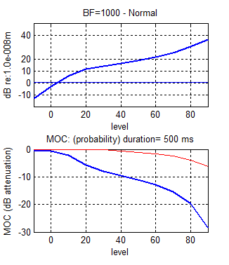
Figure 2. Top: Basilar membrane input/output function at 1 kHz. Bottom MOC and AR attenuation.

IHC apical transduction
The BM displacement is viscously coupled to the inner hair cell stereocilia displacement, u(t).

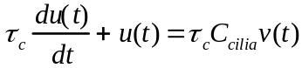
where C_{cilia} is an attenuation factor (scalar) and τ_{c} is a time constant.

The cilia displacement determines the apical conductance G(u). The total apical conductance is given by:
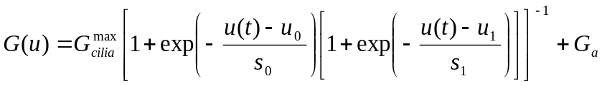
where G_{cilia}^{max} is the transduction conductance with all channels open, G0 is the resting conductance and G_{a} is the passive conductance in the apical membrane. s₀, u₀, s₁ and u₁ are constants determining the exact shape of the non-linearity.

τ_{c} (s) | 0.3e-3
Ccilia | 0.03
G^{max}_{cilia} (S) | 6e-9
u₀ (m) | 5e-9
s₀ (m⁻¹) | 30e-9
u₁ (m) | 1e-9
s₁ (m⁻¹) | 1e-9
G_{a} (S) | 0.8e-9
Table 1 IHC cilia parameters

IHC receptor potential
The membrane potential, Vt, of the cell body is modelled with a passive electrical circuit analog:

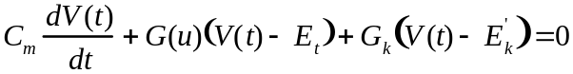
Computed as:
dV= (-Gu(V-Et) – Gk(V-Ek)) dt/Cm
V= V(-1) + dV
V= V + (-Gu(V-Et) - Gk(V-Ek)) dt/Cm

Resting V:
Gu(V-Et)=-Gk(V-Ek);
V(Gu+Gk)=GuEt+GkEk;
V0=(GuEt-GkEk)/(Gu-Gk)

where C_{m} is the cell capacitance; G_{k} is the voltage-invariant basolateral membrane conductance; E_{t} is the endocochlear potential; and E_{k}’=E_{k} + E_{t}R_{p}/(R_{t}+R_{p}) is the reversal potential of the basal current E_{k} corrected for the resistance (R_{t},R_{p})of the supporting cells.
Cm (F) | 4e-12 (Cab)
E_{t} (V) | 0.100
G_{k} (S) | 2e-8
E_{k} (V) | -80e-3
Rpc | 0.04
Table 2 IHC receptor potential parameters
- Signal frequency: 800 Hz
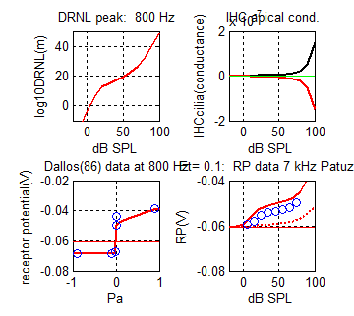
- Signal frequency: 7000 Hz
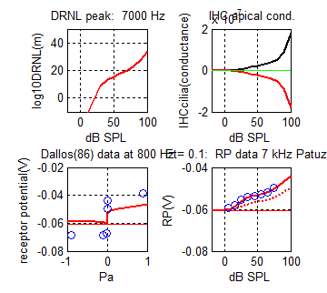
Figure 3. Receptor potential evaluation at two signal frequencies A:800 Hz and B:7000 Hz). (In each figure) Top left: DRNL input/output function. Top right: Apical conductance (Gu). Bottom left: peak and trough receptor potential at different signal levels compared with equivalent 800 Hz data from Dallos 1986. Bottom right: peak receptor potential input/ output function compared with 7 kHz data from Patuzzi and Sellick.

Pre-synaptic calcium controlled transmitter release function
The Calcium current, Ica, is determined by the membrane potential,

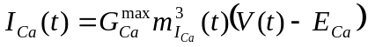

where E_{Ca} is the reversal potential for calcium and G_{Ca}^{max} is the calcium conductance in the vicinity of the synapse, with all the channels open. m_{Ica}(t) is the fraction of calcium channels that are open. Its steady state value, m_{Ica,∞}, is modelled by a Boltzmann function,
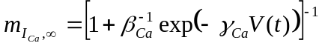

where γ_{Ca} and β_{Ca} are constants chosen to reflect published observations of calcium currents (see Table A3), and m_{Ica}(t) is a low pass filtered function of m_{Ica,∞}
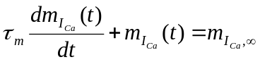

where τ_{m} is a calcium current time constant.
Pre-synaptic calcium concentration [Ca²⁺](t) is modelled as a first-order low-pass filtered function of calcium current, I_{Ca}(t)

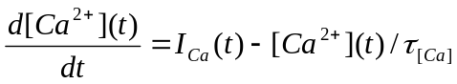 (11)

where τ_{Ca} is a time constant reflecting the dwell time of pre-synaptic calcium in the vicinity of the synapse.

The probability of the release of a transmitter vesicle is proportional to the cube of [Ca²⁺] concentration:

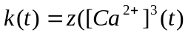) (13)

where [Ca²⁺]_{thr} is a threshold constant, z is a scalar for converting calcium levels into release rate.

τ_{Ca} controls the rate at which calcium is cleared from the region adjacent to the synapse. As a consequence it determines the release characteristics of the synapse. Low values for τ_{Ca} result in low spontaneous (LSR) synapses. HSR synapses can be modelled using higher values for τ_{Ca}. The model allows for HSR and LSR synapses to operate in parallel.
G^{max}_{Ca} (S) | 14e-9
E_{Ca} (V) | 66e-3
β_{Ca} | 400
γ_{Ca} | 100
τ_{m} (s) | 50e-6
τ_{Ca} HSR (s) | 80e-6
τ_{Ca} LSR (s) | 40e-6
z | 2e42
Table 3 IHC/AN pre-synapse calcium flow parameters

Quantal and probabilistic model of synaptic adaptation
More detailed accounts of transmitter release in a probabilistic form can be found in Meddis (1986, 1988) and Hewitt and Meddis (1991) and Sumner (2002, 2003a and 2003b). A description of the quantal version is found in Sumner (2002).

Individual vesicles of neurotransmitter (glutamate), are released from an immediate pre-synaptic (q) store into the cleft (c), at a rate, k(t), that is dependent on calcium concentration.

In the cleft, the transmitter disperses and some is lost from the system at a rate l. The remaining transmitter in the cleft is taken back into the cell into a reprocessing store (w) at a rate r. Here it is repackaged into vesicles that are returned to the immediate store at a rate x.

Additionally, q is continuously replenished with new transmitter vesicles at a rate, y[M-q(t)] where M represents the maximum number of transmitter quanta that can be held in the immediate store.

Neurotransmitter in the immediate store is quantal, and enters and leaves the immediate store stochastically. The stochastic transport of neurotransmitter is described by the function N(n,ρ), in which each of n quanta has an equal probability of release, ρ.dt, in a single simulation epoch. In the cleft and reprocessing stores, transmitter is a continuous quantity. This means, for instance, that the contents of the reprocessing store must contain at least enough transmitter to create one vesicle before a quantum can re-join the immediate store. The output from the synapse into the cleft is a stream of discrete events indicating vesicle releases, N(q(t),k(t)).
The following simultaneous equations represent the flow of transmitter through the system.

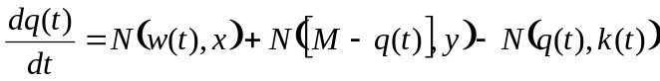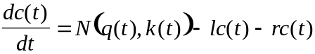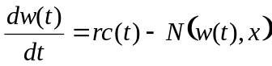

Initial values for the variable quantities are found as follows (Meddis Hewitt and Shackleton, 1990):

c₀= k₀ym/(y(l+r)+k₀l)
q₀= c₀(l+r)/k₀
w₀=c₀r/x

Where k0 is the resting value of k(t) found by evaluating equations 4 to 13 for u(t)=0.

M= | 12
y= | 6
l= | 250
x= | 60
r= | 500
refractory_period= | 0.00075

Table 4 IHC/auditory nerve synapse parameters

The evaluation of the movement of transmitter substance is computationally intensive. To ease this burden, the evaluation is normally carried out at a lower sample rate (10 kHz) following down-sampling of k(t).

If more than one type of synapse (e.g. HSR, LSR) is modeled (by employing more than one value for τ_{Ca}), independent parallel streams of AN fibers are computed.

A large number of AN fibers (>50) are computed within each channel.

Auditory nerve response
An action potential is generated in an auditory nerve whenever at least one vesicle is released into the synaptic cleft (i.e. if N(q(t),k(t)) ≥ 1) unless the fiber is refractory.
An absolute refractory period lasting 0.75 ms was applied. Thereafter, a release event was converted into a spike on a probabilistic basis as a function of time (s) since the last spike:

P_{conversion}= 1- exp(t/0.0006)

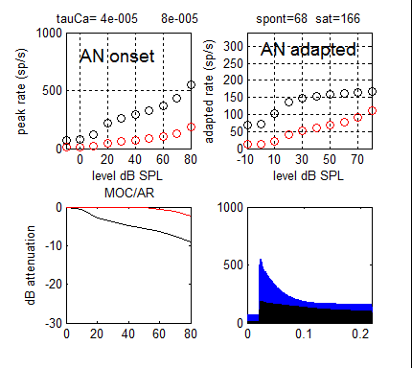
Figure 4. AN response (spiking probability) for HSR (black circles) and LSR (red circles) fibers in response to 200 ms tones at BF. Top left: onset rates. Top right: adapted rates. Bottom left: AR and MOC attenuations applied. Bottom right: PSTH for HSR (blue) and LSR (black).

Brainstem single cell responses
Single brain cell responses are modeled throughout using MacGregor’s(1987) point neuron model. This model has the advantage of simplicity and rapid execution time while retaining a modicum of flexibility so that different kinds of cells can be represented. However, the account below covers only sustained chopper responses.

The input to the cell consists of streams of action potentials from a number of sources (e.g. AN spikes). The output from the cell is a single stream of action potentials. Input and output spikes are modeled as Dirac pulses and represented as a stream of 0s and 1s. A single-cell model consists of two stages: 1) input at the dendrites and 2) spike generation at the soma.

1) The dendritic input stage converts each input spike into an alpha function to simulate a post synaptic potential

α(t) = I_{spike} .τ.t exp(-t/ τ) , (0 < t < 5 τ)
I_{spike} is the current per spike, τ is a time constant and is computed from the dendritic lowpass cutoff frequency (f) by τ = 1/(2πf).

This cutoff frequency, f, is lower for synapses on remote dendrites. Synapses close to the soma have shorter alpha functions. Sustained chopper neurons are modeled with remote synapses and have cutoff frequencies in the region of 50-100 Hz with time constants of 32-16 ms.

The alpha function is convolved with the (logical) array of input spikes to generate the post-synaptic current. The alpha functions from all input sources are simply summed to generate the input current, I_{t}.

The trans-membrane potential at the cell soma, E, is represented as a deviation from resting potential, Er, and tracked using the equation

dE(t)/dt = −E(t)/τ_{m}+I(t)R+Gk(t)[Ek–E(t)]

where τ_{m} is the membrane time constant, R is the cell membrane resistance, Ek is the potassium reversal potential relative to Er, and Gk(t) is the cell potassium conductance

An action potential is initiated when the membrane potential exceeds a threshold E(t)>Th0. This threshold is fixed throughout. The variable s is set to 1 for only a single epoch when an AP occurs, otherwise it is always 0.

Gk is tracked as follows

dGk(t)/dt = − Gk(t)/τGk + (b · s)

where τ_{Gk} is the potassium time constant, b is a step increase in Gk following an action potential indicated when s=1.

Cochlear nucleus units
Cochlear nucleus (CN) units are the first layer of brainstem cells in the model. A number of sustained units (typically 10) are computed within each BF channel. Each unit receives a number of AN fiber inputs, chosen at random (with replacement) from all available AN fibers in that channel.

The parameters of the CN units are adjusted to have a low spontaneous rate (close to 10 spikes/s) and a sustained rate of approximately 200 spikes/s at high signal levels. Sustained chopper units should show steady, equally spaced spiking activity when adequately stimulated.

If independent sets of AN fibers have been modeled (e.g. HSR and LSR), independent streams of CN units will also be computed.

Brainstem level 2 units
These units can represent cells in the inferior colliculus (IC) or medial superior olive (MSO) All of the CN units within a channel supply inputs to a single unit that represents the IC response. As a result, there is one IC unit per BF channel. If more than on AN fiber type is modeled, a separate IC unit is modeled for each fiber type, one for each fiber type.

The parameters of the IC units are adjusted so as to have a zero spontaneous rate but a threshold as close as possible to the AN rate/level threshold.

f | 50 Hz
I_{spike} | 35e-9 A
τ _{m} | 2e-3 s
τGk | 0.0005
b | 133e-6 S
Th0 | 0.01
R | 60e6 Ω
Ek | -0.01 V
Eb | 0.06 V
Er | -0.06 V
Input fibers | 10
Table 5 CN neuron parameters (sustained chopper response).
f | 100 Hz
I_{spike} | 40e-9 A
τ_{m} | 2e-3 s
τGk | 1.2e-3
b | 133e-6 S
Th0 | 0.01
R | 60e6 Ω
Ek | -0.01 V
Eb | 0.06 V
Er | -0.06 V
Input fibers | 10
Table 8 MacGregor IC neuron parameters
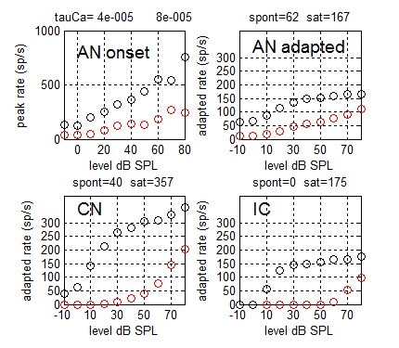
Figure 5. Rate/ level functions for auditory nerve fibers, first and second level brainstem units. Two streams are represented, HSR (black) and LSR (red). The tests are based on 200-ms tones at BF (=1 kHz). AN onset rate is based on spikes in the 1-ms bin with the most spikes. Other panels are adapted rates based on the final 100 ms.

Acoustic reflex
This topic is under active development and the author should be consulted for the latest picture.

The acoustic reflex (AR) is an attenuation applied to the stapes displacement. The amount of attenuation is based on the single brainstem level 2 activity in the LSR stream. This is intended to represent MSO units that receive inputs from CN (chopper?) units receiving input from LSR AN fibers. The choice of LSR AN fibers as the source is simply to guarantee high thresholds.

The attenuation is based on the mean (across all BFs) of the activity in all level 2 units in the LSR stream. This sum is smoothed using a lowpass filter with a time constant of 250 ms (cutoff 0.6 Hz) to create a value r(LSR)_{t}, and then adjusted using a scalar (currently 0.008) to generate a gain factor, AR_{t}

AR_{t} = 1 - 0.008 r(HSR)_{t}

which will be applied to the stapes displacement.
Because r(HSR)_{t} is intended to be a cross-frequency measure of AN activity, it should be clear that this estimate is more accurate when a large number of filters is used across a wide range of BFs.

MOC reflex
The MOC reflex is an attenuation applied to the BM displacement. An independent attenuation is computed for each BF channel. The attenuation is computed on the basis of brainstem level 2 neurons in the HSR stream. This guarantees relatively low thresholds of activation.

There is only one level 2 unit in each channel and its firing rate is the sole basis for computing the MOC efferent activity in the corresponding channel. The spiking activity is smoothed using a lowpass filter with a time constant of 25 ms (cutoff 6 Hz) to create a value r(HSR)_{t}, and then adjusted using a scalar (currently 0.0063) to generate a gain factor, MOC_{t}

MOC_{t} = 1 - 0.00863r(HSR)_{t}

which will be applied to the BM displacement for the corresponding BF channel.

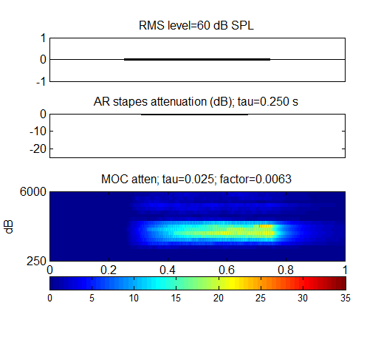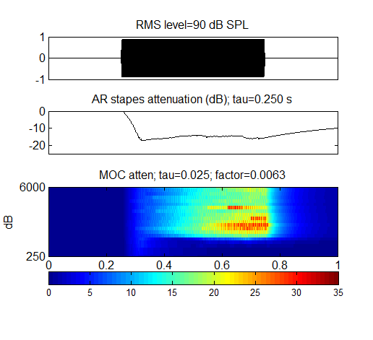
Figure 6. AR and MOC attenuation for a multi-channel model. Top panel:60-dB SPL, 1-kHz pure tone. Bottom panel: 90-dB SPL 1-kHz pure tone.

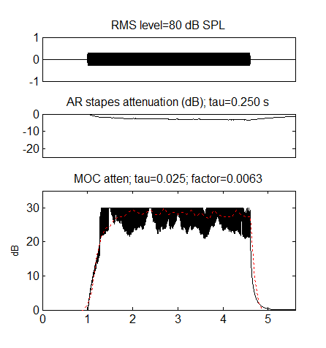
Figure 7. MOC attenuation fitted to Lieberman (1988) data as a time constant check.

Detection of a sound stimulus
A stimulus is deemed to have been detected if any one of the IC units produces at least one action potential during or very soon after the stimulus.

